- Go to www.doverlittleleague.com
- Click LOGIN (if you have an account) or REGISTER (if you need to create one)
  - NOTE: Each volunteer must have their own account in the system
- Enter the required information.
- Select VOLUNTEER on the left side of the screen
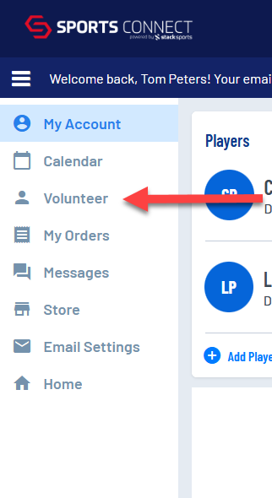
- Select FIND VOLUNTEER ROLES
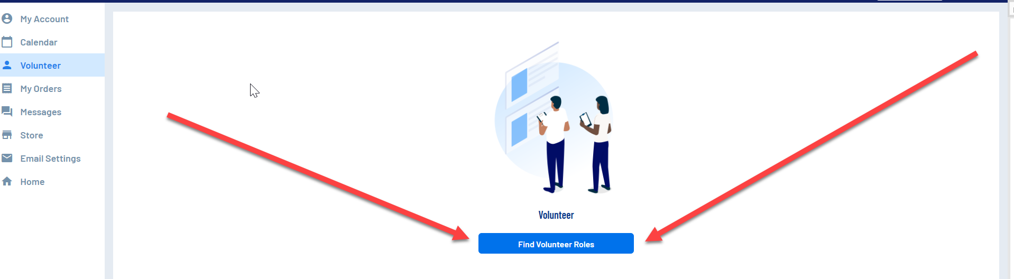

- Select the sport you wish to volunteer.
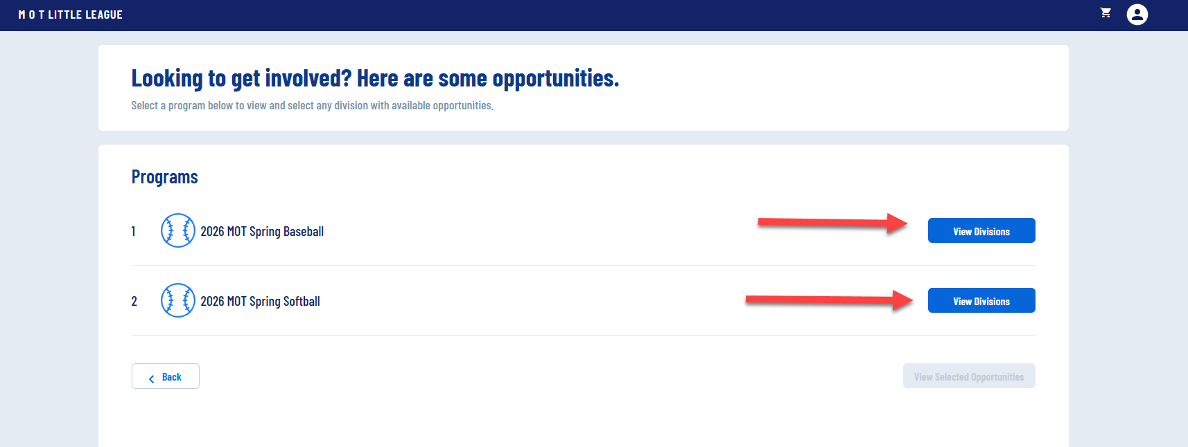
- Select the divisions you wish to volunteer and click VIEW SELECTED OPPORTUNITIES

- Select the desired role.
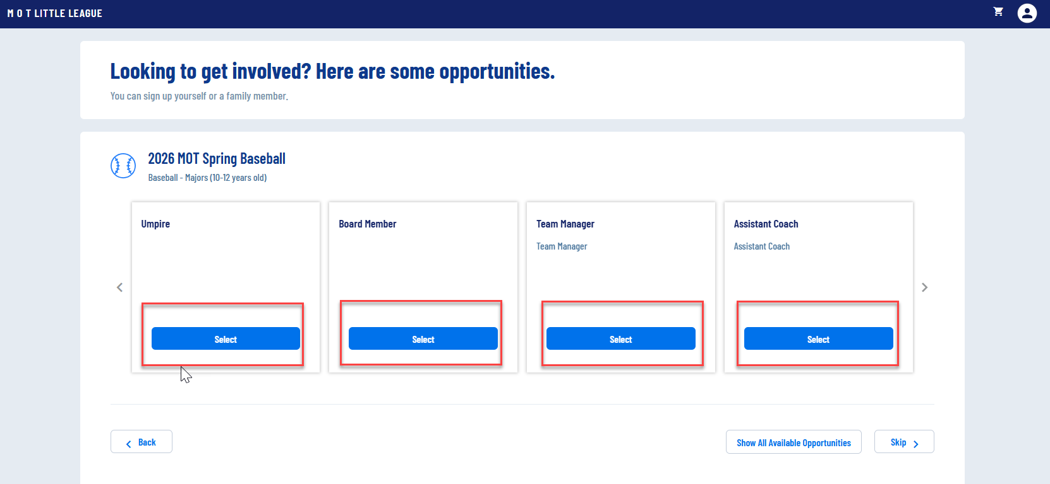

- Determine if you are signing up a registered user or a new user.
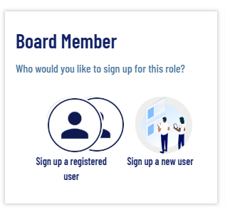
- Select the registered user or enter the information for the new user.
- Click CONTINUE
- Complete the Volunteer Application Form. You will need to upload your Government Issued ID AND Abuse Awareness Training Completion Certificate. (Please complete the course before completing the volunteer application. It will need to be uploaded to the site. Instructions on completing the course are on the next page)
- Click CONTINUE. Once completed you will see the following screen:
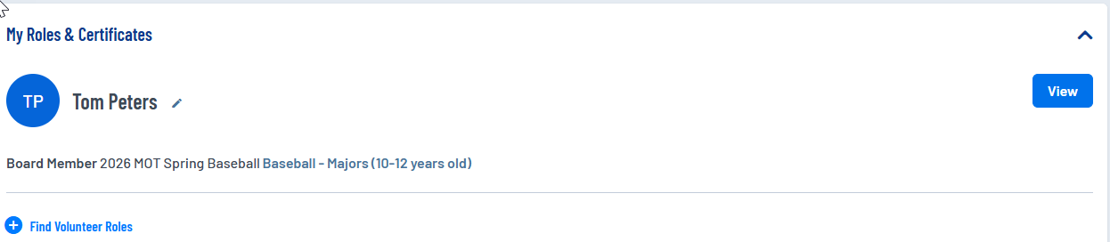
- You will receive an e-mail from Dover Little League confirming your registration.
- You will then receive another e-mail from Dover Little League within 2 – 3 days with the link to complete your background check. Please do this ASAP, as you will only have 14 days to complete it. Once complete, you will receive an e-mail confirmation.
- Check the Cleared To Volunteer page on doverlittleleague.com to confirm your volunteer status. If your name is not on the site, it is likely that one of the required elements has not been completed.

If you have any questions or issues, please contact doverlittleleagueboard@gmail.com.
NOTE: You will not receive the background check results.

Directions for Completing Little League’s Abuse Awareness Training

In addition to your background check, this training is MANDATORY for ALL Little League volunteers. Anyone not completing this training will be ineligible to manage, coach, keep score or assist the team or league in any capacity.
1) Go to LittleLeague.org/AbuseAwareness.
2) If it's your first time logging in, CREATE AN ACCOUNT to begin.
3) Search for Dover Little League as your league.
4) Once your account is created, LOGIN TO TRAINING PORTAL.
5) Select the ABUSE AWARENESS 2026 training by clicking ENROLL.
6) Select Volunteer or League Official (if you are a Board member) and complete the course. It should take about 30 minutes to complete.
7) Take the quiz at the end of the course. You must score at least 80% to pass.
8) When finished, you will receive a completion e-mail from Little League. Please download the attached completion certificate and upload it to your volunteer profile / account on Doverlittleleague.com
9) Check the Cleared To Volunteer page on doverlittleleague.com to confirm your volunteer status. If your name is not on the site, it is likely one of the required elements has not been completed.
If you have any questions or issues, please contact doverlittleleagueboard@gmail.com

